**Envisioning A World Where Lazy People Ride Bikes**

Sage Dewdney

April 28, 2016 Version 1.1

**1. Introduction**

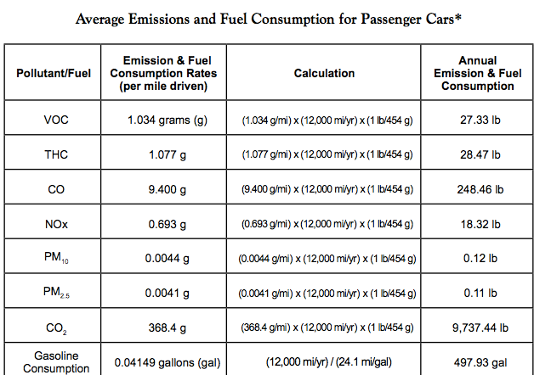Worldwide, the most popular means of transportation is by car. Every day, billions of people drive to work, to school, to the grocery store, and many other places. Growing up I considered owning and driving a car a fundamental part of adulthood. Almost everyone drove, regardless of distance. Driving a car is fast, easy and comfortable. Cars are amazing but they have a major problem, the environment cannot support the way we drive. As seen in the chart from the US EPA to the right, the average amount of carbon dioxideemitted by a single passenger car is around 10,000 lbs/year.[1] These emissions wreak havoc on the environment; the EPA estimates that these carbon dioxide emissions alone represent over 25% of the total US greenhouse gas emissions.[2]

Figure .1: Average emissions for passenger cars

Climate change is one of the biggest issues of our time; it represents a global problem plaguing wildlife, agriculture and the health of everyone on the planet. As such, change is absolutely necessary, and vehicle emissions are an obvious place we can greatly reduce our current contribution to climate change. We can’t just stop driving entirely, but we could significantly reduce how much we travel by car. When you consider that cars account for 60% of trips of a mile or less[3] and almost 50% of trips made in the US are under 4.8km it becomes clear that by reducing the number of short trips made by car, we could significantly reduce greenhouse gas emissions.[4]

One of the ways we could reduce the number of short trips made by car is by biking instead. Bikes offer major advantages over cars: there are numerous health benefits to riding a bike, they are much cheaper than driving, and they have next to no greenhouse gas emissions. Regular cycling has been shown to elevate mood, reduce body fat levels, and improve posture coordination, strength, flexibility, bone density and joint mobility as well as prevent the risk of several diseases.[5] When you consider the benefits of regular cycling, it really begs the question “Why don’t we ride our bikes more?”

Most of the benefits of cycling are obvious, but people still choose to drive instead. Growing up I had a neighbor named Tim who was a huge advocate of replacing short trips with regular bicycle rides. He simply couldn’t see why people didn’t choose to ride a bike instead of drive for something like a trip to the grocery store. Tim taught at my high school and would always try to get me to ride to school in the morning with him. He’d say things like “it’s only a 5 mile trip” or “it’s really invigorating and wakes you up for the day”. Tim is a great guy, but I hated him every time he said that. For some reason, Tim could not understand one simple truth: unless I had no other choice, I was going to drive my car- I am far too lazy to bike everyday.

Suggesting that I ride my bike to school everyday sounded like a ridiculous proposition to me. If I started listing off everything wrong with that idea when I left for school in my car, I would not be done by the time I arrived. My school was only 5 miles away, a completely reasonable bike trip for a young, healthy high-schooler, but for some reason my neighbor Tim didn’t see all the same great reasons to drive that I did. Driving is faster; including warming up my car it took around 7 minutes to get to school everyday vs. 45 to bike. Driving is easier; in my car I don’t even notice the steep hill that accounts for the last mile of the ride. Driving is even more comfortable; I have a cushioned chair, speakers and a heater that all make the experience way more pleasurable. Tim had the same problem with me that he had with many people, there’s just no way to convince me to ride my bike instead of drive. I’m too lazy.

People like me represent an interesting challenge in getting people to switch to cycling for short trips. Besides having the universally applicable infrastructure and safety requirements to choose a bike over a car, we have additional “lazy requirements” to ride a bike instead of driving. We want to stay clean, have a comfortable ride, have a short trip duration, and we want to never have to work hard to travel somewhere. New technology can address many of those problems easily, but it comes with an extra cost. If we want a world where the majority of people ride bikes instead of drive for a short trip we need to consider all of the costs associated with it: the infrastructure requirements, safety requirements, and the lazy requirements.

**2. Infrastructure Requirements**

One of the biggest problems for those who currently choose to ride their bike is that local infrastructure cannot adequately support cyclists. 3 major infrastructure changes would have to occur to properly support cycling in most cities. To make cycling possible cities need bike lanes and parking, as well as separate over and underpasses.

Creating more bike lanes represents an interesting challenge because they are prohibitively expensive. Prices to construct a standard, permanent bike lane ranges from $5,000 to $535,000 per mile with an average cost of $135,000 per mile.[6] Further, bike lanes also carry the problem of being really hard to plan. Civil engineers need to consider lane width, traffic patterns and all traffic controlling devices to design a bike lane. Retrofitting cities with bike lanes adds another problem, the construction of a bike lane requires impeding traffic flow for up to a few weeks.

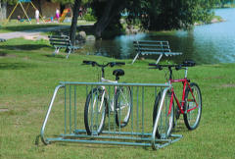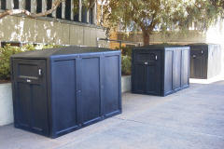Bike lanes are absolutely useless if people cannot park their bike near their destination, which introduces another cost, parking. Bike parking comes in many forms like the bike rack seen on the left in Figure 2.1, or the bike locker to the right in Figure 2.1. Each has its own benefits and drawbacks. For instance, the rack on the left is cheap at around $790 per unit for a ten-bicycle rack. Further those racks are semi-portable and space saving compared to other means of bike parking. Bike lockers like those on the right are considerably safer; your bike is well protected from thieves and the elements alike. However these lockers are essentially permanent installations and they cost around $208 per locker and each locker only stores 1 bike. Further, a 1-bike locker takes up about the same amount of space as a 3-bike locker that is fully in use.

Figure .1: Types of bike parking

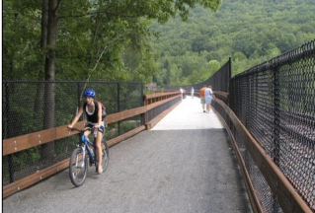Another cost associated with developing local infrastructure to support bicycles is developing over and underpasses to allow for bike traffic near busy areas or over small obstacles like a stream. The cost for an overpass/underpass is around $150,000 for a wooden bridge, and around $400,000 for a pre-fabricated steel and concrete bridge.[7] Such structures are much more rare than parking or a bike lane, but when they are used, they are generally necessary because of highways, railways and natural barriers. They represent a very high, unavoidable cost in most cities attempting to improve bicycle infrastructure.

Figure 2.2 a wooden overpass

**3. Safety Requirements**

Even if bike lanes, overpasses and parking were all implemented overnight, biking to work the next day in your city would still be a bad idea. There are additional safety concerns that need to be accounted for when creating a bike friendly environment. As seen in the chart from the League of American Cyclists below, reducing the number of crashes and fatalities is one of the key outcomes in building a bicycle friendly community. Using case studies from bike friendly communities like Denmark and Copenhagen, we can create a list of additional changes we can make to reduce the number of bike related fatalities.

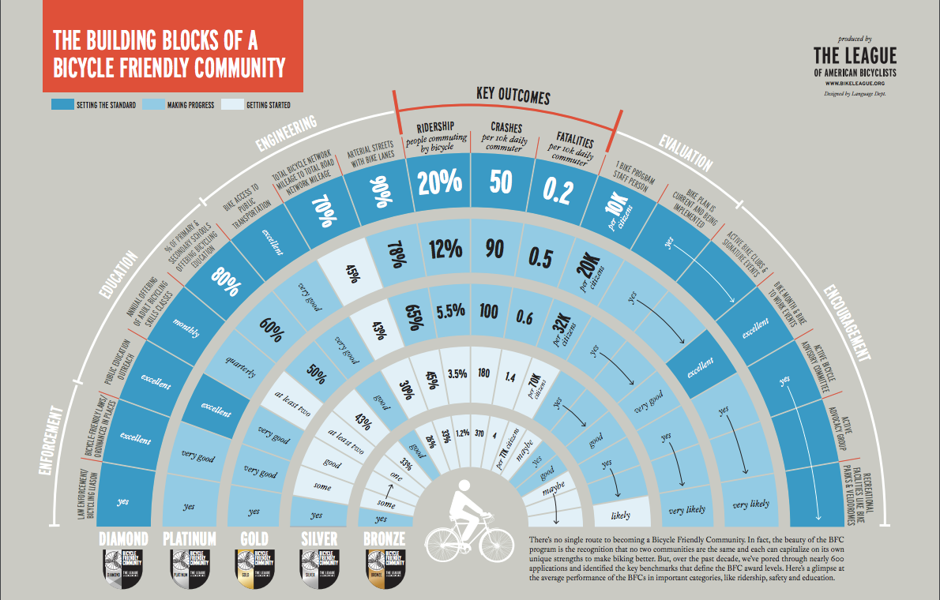

Figure .1: Requirements of a bike friendly community

The first big change that needs to be made to effectively create safe roads for bicyclists is educating drivers and cyclists regarding the laws in their community. In many areas cyclists are so rare that drivers are unfamiliar with the laws regarding cyclists. In Oregon, which is considered one of the most bike friendly states in the US, several important laws exist to protect cyclists. Among those laws are a safe passing law which requires drivers pass any cyclist like they would a car, but with greater following distance before entering the passing lane and with greater distance between the bike and car when merging. Oregon also has a helmet law requiring cyclists wear helmets on busy streets and at all times if they are under 16, and it also has a vulnerable user law increasing the penalty to any driver guilty of careless driving. Oregon also has a law allowing cyclists to ride on a pedestrian free sidewalk if there is no bike lane.[8]

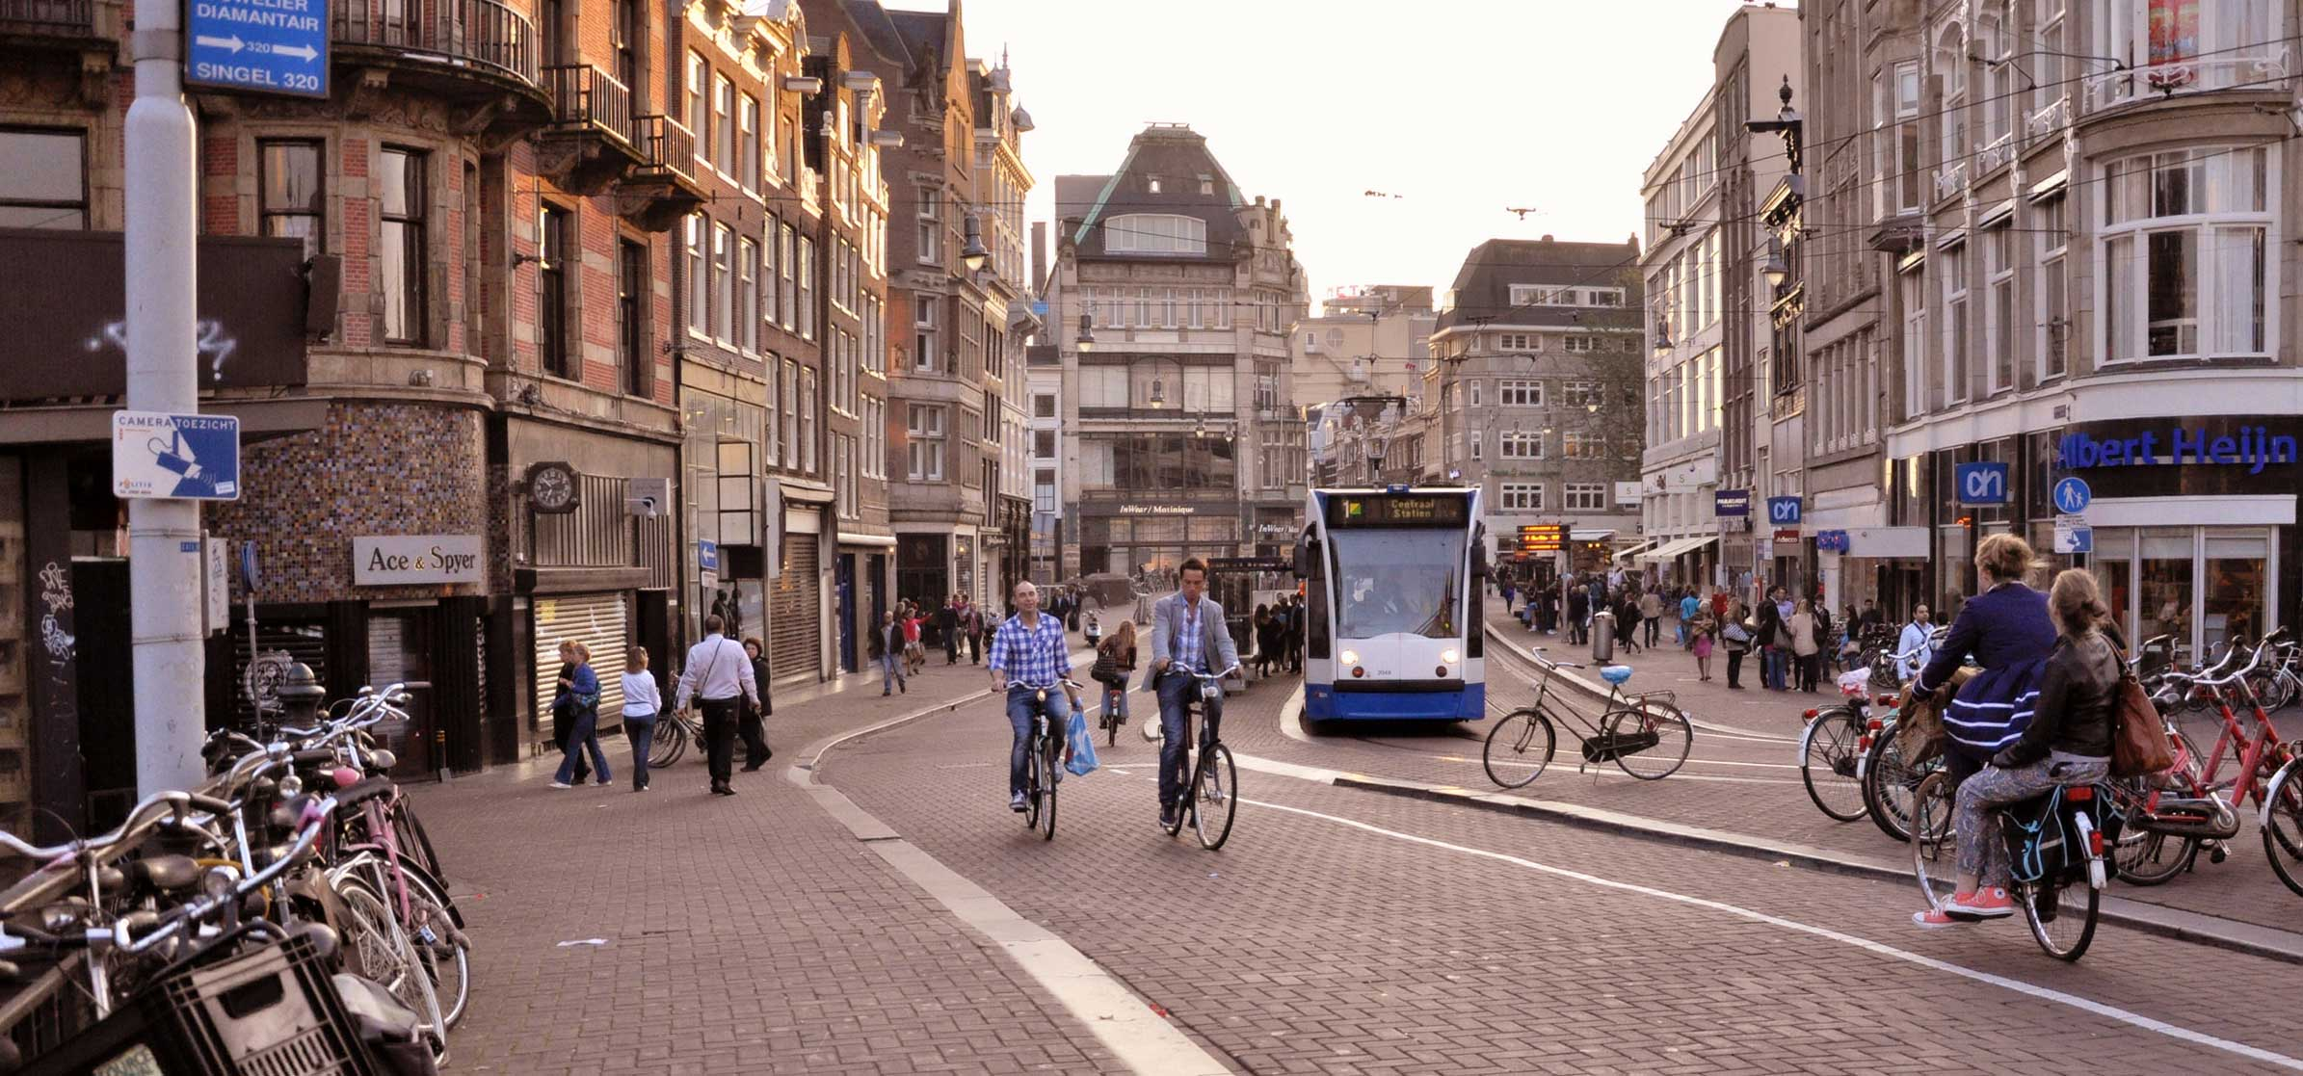Besides educating people about safe bike practices, there are also several safety related infrastructure changes that can lead to significantly safer roads for everyone. In Copenhagen, city designers have found that a further reduced speed limit in cities leads to a significant reduction in both car and bicycle crashes. They also found that a few city design techniques like implementing different road textures, winding roads, speed bumps and roundabouts can all calm traffic patterns and make the roads much safer for everyone. Not only would these changes reduce the number of bike accidents, they would also reduce the number of car accidents in cities as well as protect pedestrians. The final recommendation that can be made looking at Copenhagen’s city design is to seriously consider when and if the bike lane should diverge from the road. In some cases it is both safer and cheaper to keep the bike lane and road on the same path, but in areas of high-speed traffic, roads and bike lanes should diverge completely. Not only will cyclists feel much safer and therefore be more likely to ride their bike after changes like these, they will also benefit from those changes by being safer walking or driving as well.

Figure 3.2: A bike lane in Copenhagen shows winding roads with textured patterns and separation from high-speed traffic

**4. Lazy Requirements**

After bike lanes exist and are safe to use, we’re left with one problem. Only a few people are really motivated enough to use them. Justifying the costs associated with the necessary infrastructure changes and re-education is hard when few cyclists will take advantage of them. Luckily, emerging technologies offer several advantages over traditional cycling. A modern commuter bike is a lot easier and more comfortable to ride than the classic, cherry red flyer of many people’s childhood. Further, an even better solution to the commuter bike is becoming more and more popular, the e-bike. E-bikes address major obstacles to regular bike usage by removing most of the difficulty in riding up hills or pedaling for a long trip.

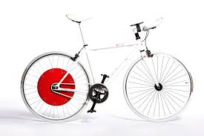One promising style of e-bike is called the Copenhagen wheel. It started with MIT students who were inspired by the popularity of cycling in Copenhagen that recognized the flat terrain of Copenhagen is a huge factor in the popularity of cycling there. Hills represent a major obstacle to the popularity of cycling because they represent a very strenuous part of the trip where a cyclists have to work harder to travel slower, but the Copenhagen wheel can eliminate those difficulties. The Copenhagen wheel can retrofit almost any bike by replacing the rear bicycle wheel. Once replaced, the wheel can augment foot-pedaling power by 3-10Xs a normal cyclists output via the small motor contained within. The revolutionary thing about the Copenhagen wheel is that it is adaptive. The wheel connects to your smart phone and as you use, it learns when you could use a boost. If you struggle with hills or would prefer that long flat stretches go faster the wheel learns your preferences and changes its power output to match what is best for you. Further, the wheel is entirely programmable, so anyone with CS knowledge can adapt it however they wish. The wheel takes about 4 hours to charge via a normal household outlet and a single charge can last around a month with extended daily use. The Copenhagen wheel achieves this extraordinary feat by storing mechanical energy that would otherwise be wasted. For instance, when going downhill or braking, a small amount of that energy is devoted to recharging the wheel so it can be used as needed later on. Not only can the Copenhagen wheel be used to retrofit any bike, it only costs around $950 per wheel at the current sale price.[9]

Figure .1: a Copenhagen Wheel attached to a standard bike

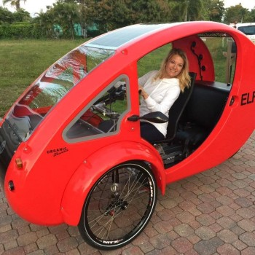Technology like the Copenhagen wheel can make bicycling much easier and faster with minimal environmental impact, but it still doesn’t address comfort concerns. When my neighbor Tim would try to get me to bike to school with him, one of my primary objections was comfort. It was often raining, or there were puddles on the ground, which meant getting wet and then changing clothes when I got to school. I also wasn’t particularly in love with the idea of sitting on a seat as small, hard and pointy as a bike seat. One company that seeks to address that problem is called Organic Transit. Based in North Carolina, Organic Transit seeks to make bicycling a viable option by combining the benefits of an e-bike with a solar powered roof charger and a fully enclosed and cushioned seat. As seen in Figure 4.2 to the right, the Elf is a revolutionary style of bicycle boasting turn signals, an enclosed protective dome and fantastic suspension. The Elf is not only safer and easier to ride, it also has 0 net emissions because it is powered entirely by mechanical energy and solo power. The model of the Elf seen in Figure 4.2 costs around $6,000 but can also be purchased in a 2-seater version for $8,000 or a tactical police version for around $10,000.[10]

Figure 4.2 The Elf solo

Technologies other than the Copenhagen wheel and the Elf exist, the most common option being the more traditional electric assist bike. Traditional bikes offer many advantages over options like the Copenhagen wheel because they are designed from the ground up with electric assist in mind. Besides being more efficient in energy usage, traditional bikes also boast better sensing technology. Modern electric assist bikes can combine a torque sensor with a cadence sensor attached to the pedals and as a speed sensor to gather more data and better predict how much assistance is required. Further, they often have throttle-like controls on the handlebars to allow for manual control. The major drawback associated with the traditional style of e-bike is the cost. Most quality e-bikes cost upwards of $3,000 and they don’t outperform technology like the Copenhagen wheel well enough to justify a purchase for many people. The difference in performance is almost negligible between a Copenhagen wheel and a full e-bike yet assuming a potential customer already owns a bike, a traditional e-bike costs around 3 times more for the same benefit. Further, most e-bikes don’t offer app integration, energy recycling, or adaptive software that learns how you ride. So while the traditional e-bike is the most popular option now, it will likely be phased out as competitors redefine the bike industry.

Current advances in technology offer insight into how the cycling experience can easily be improved. The Copenhagen wheel offers a cheap, easy way to get into the e-bike community and the Elf represents a more expensive, luxurious option, but both are effective solutions to eliminate many of the key complaints lazy people like me have. Not only do they represent potential solutions to many of our current problems, they also demonstrate that there is a lot of room for innovation in the commuter cycling industry.

**5. Paying for it all**

Updating an entire city’s infrastructure, educating drivers, and changing city design all represent expensive challenges that a city needs to pay for in order to be bike friendly, and considering effective methods of collecting the money is important to the success of any bike program. Current solutions include a bicycle tax, an emissions tax, increased toll roads, increased car registration fees and just a general tax increase.

In some Californian cities, officials are in favor of a bike registration process that operates much like your standard car registration.[11] Every couple years an individual would be required to update the tabs on their bicycle as well as pay a small fee, and those fees could help pay for the changes to infrastructure. While those fees seem counterproductive to encouraging cyclists to ride regularly, they could easily be implemented once a cycling program was already thriving to help pay for maintenance costs associated with all the infrastructure improvements. Further, bike registration would reduce theft and improve bicycle retrieval rates after thefts have occurred.

An emissions tax proportional to your cars’ greenhouse gas emissions could also be a possible solution to help pay for the cost of adding and maintaining bicycle infrastructure. Such a tax would not only help pay for bicycle related renovations in cities, it would also discourage people from driving cars with high emissions. Along the same line, another fee could target people who drive regularly by increasing the number of toll roads in areas that could be easily biked.

**6. Conclusion**

The emissions associated with driving a car on a day-to-day basis for short trips are an easily eliminated major contributor to global warming. By properly implementing a well-designed tax plan, we could easily build bike friendly cities with the infrastructure and safety requirements to make biking to work and the grocery store an everyday reality. Further, advances in technology like e-bikes make such trips much more likely for your average unmotivated person to be convinced to make their primary mode of transportation a bike. Many people could easily be convinced to make the switch because the new technologies that are being developed and the advantages of lower costs as well as numerous health and environmental benefits associated with daily biking are exceptional.

[word count: 3164

1. “Average Annual Emissions and Fuel Consumption for Gasoline-Fueled Passenger Cars and Light Trucks.” *US Environmental Protection Agency* n.d.
2. “Overview of Greenhouse Gases.” *US Environmental Protection Agency*. 2016. https://www3.epa.gov/climatechange/ghgemissions/gases/co2.html.
3. Flusche, Darren. “National Household Travel Survey.” *The League of American Bicyclists*. 2010. http://www.bikeleague.org/content/national-household-travel-survey-short-trips-analysis.
4. Buehler, Ralph. In *Transport Policies, Travel Behavior, and Sustainability: A Comparison of Germany and the U.S.*, 360–65. New Brunswick, New Jersey: Rutgers Graduate school2008.
5. “Cycling - Health Benefits.” *Department of Health & Human Services, State Government of Victoria, Australia*. 2013. https://www.betterhealth.vic.gov.au/health/healthyliving/cycling-health-benefits.
6. “Bicycle Lanes.” *US Department of Transportation Federal Highway Administration*. 2015. http://www.pedbikeinfo.org/planning/facilities_bike_bikelanes.cfm.
7. Bushell, Max A, Bryan W Poole, Charles V Zeeger, and Daniel A Rodriguez. “Costs for Pedestrian and Bicyclist Infrastructure Improvements: A Resource for Researchers, Engineers, Planners, and the General Public.” *UNC Highway Safety Research Center*2013. http://www.pedbikeinfo.org/cms/downloads/Countermeasure%20Costs_Report_Nov2013.pdf.
8. “State Bike laws.” *League of American Wheelmen*. 2015. http://bikeleague.org/StateBikeLaws.
9. “The Copenhagen Wheel.” *Superpedestrian*. 2016. https://www.superpedestrian.com/.
10. “Home Page.” *Organic Transit* n.d. http://organictransit.com/.
11. “Best Practices.” *National Crime Prevention Council*. 2015. https://www.nationalbikeregistry.com/crime.html.